Email Verification Token

📧 What Is an Email Verification Token?
# Source: AI Source: Provided by: [Data Path: Persons Table -> ID Column: 1, Name_En Column: Motasem Essam] -> From: [Chatgpt (GPT‑5 Mini)] on [1/20/2026]
An Email Verification Token is a unique code or link sent to a user's email address to confirm that they own that email — typically during signup, password reset, or when changing emails.

✅ Simple Definition:
# Source: AI Source: Provided by: [Data Path: Persons Table -> ID Column: 1, Name_En Column: Motasem Essam] -> From: [Chatgpt (GPT‑5 Mini)] on [1/20/2026]
It’s a temporary token included in a special email link to verify a user's email address.

🧠 Real-Life Analogy:
# Source: AI Source: Provided by: [Data Path: Persons Table -> ID Column: 1, Name_En Column: Motasem Essam] -> From: [Chatgpt (GPT‑5 Mini)] on [1/20/2026]
Imagine signing up for a bank account online:
- They send you a letter with a confirmation code
- You must enter the code or click a link to prove it’s really your address
Same thing with an email verification token — but digital.

🔄 How It Works
# Source: AI Source: Provided by: [Data Path: Persons Table -> ID Column: 1, Name_En Column: Motasem Essam] -> From: [Chatgpt (GPT‑5 Mini)] on [1/20/2026]
- User signs up or updates their email
- Backend generates a secure, random token (e.g., UUID or hash)
- Token is stored temporarily in the database with:
  - Expiry time (e.g. 24 hours)
  - Related user ID
Email is sent with a link:
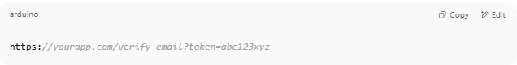
https://yourapp.com/verify-email?token=abc123xyz

- User clicks the link
- Backend checks:
  - Is the token valid?
  - Is it expired?
  - Does it match a user?
- If all good, mark email as verified ✅

🧾 Example Token
# Source: AI Source: Provided by: [Data Path: Persons Table -> ID Column: 1, Name_En Column: Motasem Essam] -> From: [Chatgpt (GPT‑5 Mini)] on [1/20/2026]
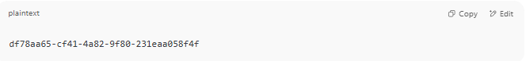
df78aa65-cf41-4a82-9f80-231eaa058f4f

🔒 Security Best Practices
# Source: AI Source: Provided by: [Data Path: Persons Table -> ID Column: 1, Name_En Column: Motasem Essam] -> From: [Chatgpt (GPT‑5 Mini)] on [1/20/2026]
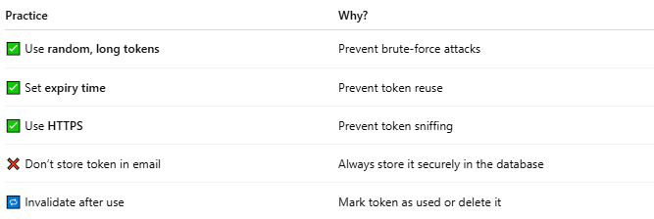

Practice | Why?
✅ Use random, long tokens | Prevent brute-force attacks
✅ Set expiry time | Prevent token reuse
✅ Use HTTPS | Prevent token sniffing
❌ Don’t store token in email | Always store it securely in the database
🔁 Invalidate after use | Mark token as used or delete it

📦 Where It’s Used
# Source: AI Source: Provided by: [Data Path: Persons Table -> ID Column: 1, Name_En Column: Motasem Essam] -> From: [Chatgpt (GPT‑5 Mini)] on [1/20/2026]
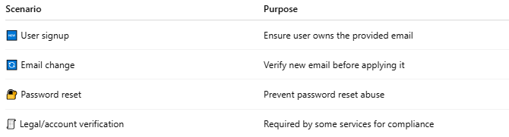

Scenario | Purpose
🆕 User signup | Ensure user owns the provided email
🔄 Email change | Verify new email before applying it
🔐 Password reset | Prevent password reset abuse
🧾 Legal/account verification | Required by some services for compliance

📌 Summary
# Source: AI Source: Provided by: [Data Path: Persons Table -> ID Column: 1, Name_En Column: Motasem Essam] -> From: [Chatgpt (GPT‑5 Mini)] on [1/20/2026]
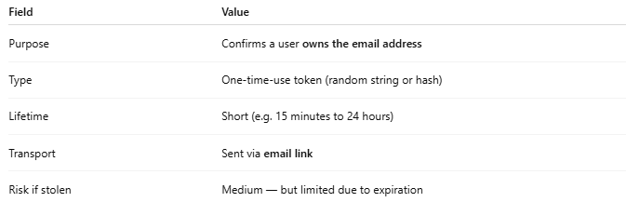

Field | Value
Purpose | Confirms a user owns the email address
Type | One-time-use token (random string or hash)
Lifetime | Short (e.g. 15 minutes to 24 hours)
Transport | Sent via email link
Risk if stolen | Medium — but limited due to expiration

